

2019

Lab 1: Introduction to lab environment

Prepared by:

Dr. Mohammed Al-Sarem

Dr. Muhanad AlMohameed

Taibah University, Information System

Department

11/8/2019

Lab Exercise 1: Introduction to Lab Environment

Lab Objectives:

The aim of this lab is to introduce you to the programing environment that we will be working on throughout the whole course and next Labs. At the end of this lab, the students will be able to:

- install jupyter editor and explore its possibilities in educational purpose.

- add Markdown notes, and how to mix your code with markdown.

Methodology

In class task:

Tasks you will complete in this lab exercise include:

- Install the Jupyter Editor on different OS including Windows 10, Unix and Macintosh.

- Explore the functionality of Jupyter Editor.

- Lunch Jupyter Editor in your web browser and link it with Anaconda environment.

home task:

References:

For more information, students are encouraged to visit the official Jupyter website on: https://jupyter.readthedocs.io/en/latest/

1
All copyrights are reserved to:

Dr. Mohammed Al-Sarem & Dr. Muhanad Al-Muhameed

Lab Exercise 1: Introduction to Lab Environment

1 Environment Installation

1.1 Try in Your Browser. No Installation Needed.

- Go to https://jupyter.org/try No installation is needed.

- You can try it without installation. Click on Jupter icon in Try JupterLab block.
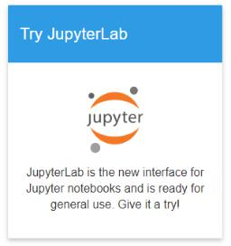

This will redirect you to a demo example which might take a time to open depend on speed of your computer. Your task is to explore the environment. Take your time!

1.2 Install Jupyter in your PC

This lab is organized to run on jupyter version 4.1. To Install Jupyter, the Anaconda environment are highly recommended. The default Python version that we will used throughout the whole course is 3.7. So, choose the right version that is fit to your PC configuration.

1.2.1 Jupyter Installation on Windows 10

Before starting download Anaconda environment, look to your PC settings to define which version is fit well to the OS. To do that:

- Go to Control Panel and seek System Item, you will see basic information about your PC.

- Look at System type, noted that you are now ready to visit anaconda website at: https://www.anaconda.com/

- At the top right side of your screen, you will find download button. Click on it and choose the right version that fits your PC. Remember that we use Python 3.7 version. However, at this step it is not matter since we don’t until now work on Python libraries.
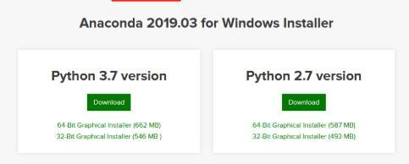

2
All copyrights are reserved to:

Dr. Mohammed Al-Sarem & Dr. Muhanad Al-Muhameed

Lab Exercise 1: Introduction to Lab Environment

- Wait until the download is finished, then go to the folder where you saved the application and click on Anaconda3-2019.10-Windows-x86_64. The setup will guide you through the installation.
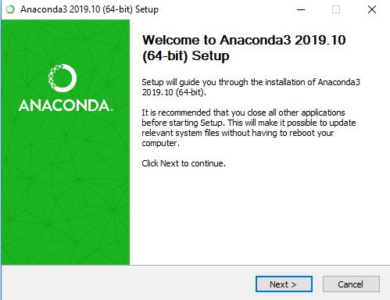

- It is recommended to change the destination folder to C:\ Anaconda3, then click on Next.

- Check the box “Register Anaconda as my default Python 3.7”, then click on

Install.

- When the installation is successfully complete, your browser will redirect you to two websites: https://docs.anaconda.com/anaconda/user-guide/getting-started/ and https://anaconda.org/. If you have not an account in anaconda, fill the required information to create an account either sign up using your existing information. This step is not necessary, but I recommend to do that.


- Now, go to Anaconda application and choose Jupyter Notebook (Anaconda 3).

3
All copyrights are reserved to:

Dr. Mohammed Al-Sarem & Dr. Muhanad Al-Muhameed

Lab Exercise 1: Introduction to Lab Environment
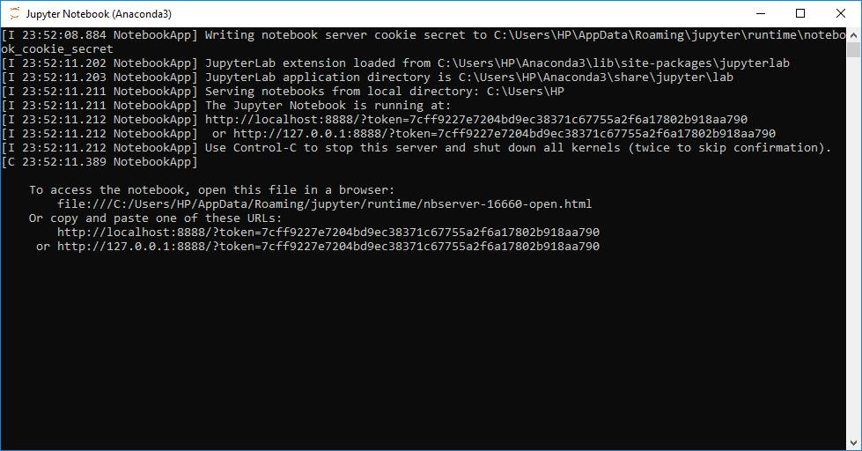

- Copy the URL shown in the picture above on to your browser. This will open a webpage that we will use it in our later work. You can lunch Jupyter by opening the program and you lunching the Jupyter editor allocated on Anaconda navigator screen.

- Take your time to explore the webpage and all its controls.

1.2.2 Jupyter Installation on Unix

1.2.3 Jupyter Installation on Macintosh

- Visit anaconda website at: https://www.anaconda.com/

- At the top right side of your screen, you will find download button. Click on it. Remember that we use Python 3.7 version. However, at this step it is not matter since we don’t until now work on Python libraries.
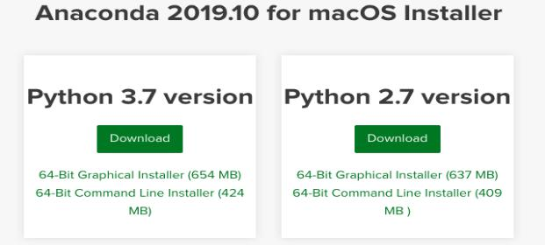

- Wait until the download is finished, then go to the folder where you saved the application and click on Anaconda3-2019.10-MacOSX-x86_64.pkg. The setup will guide you through the installation.

4
All copyrights are reserved to:

Dr. Mohammed Al-Sarem & Dr. Muhanad Al-Muhameed

Lab Exercise 1: Introduction to Lab Environment
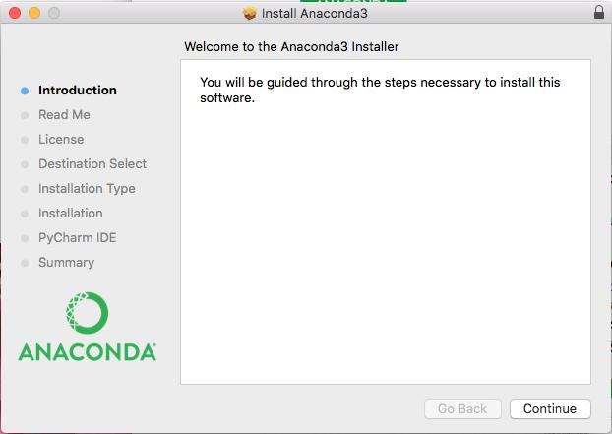

- When the installation is successfully complete and before closing setup page, you will be asked whether you have an account in Anaconda. If you do not have an account, fill the required information to create an account either sign up using your existing information. This step is not necessary, but I recommend to do that.

- Now, go to Anaconda application and launch Jupyter Notebook.

5
All copyrights are reserved to:

Dr. Mohammed Al-Sarem & Dr. Muhanad Al-Muhameed

Lab Exercise 1: Introduction to Lab Environment
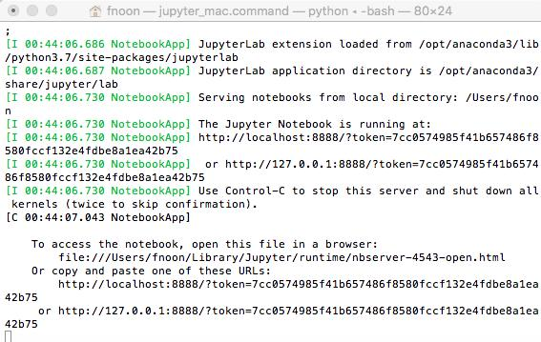

- Your default browser will be launched and a new Jupyter session will be created.

Take your time to explore the webpage and all its controls.

2 Working with Markdown in Jupyter Notebook

In the previous section, we learnt how to install and open the Jupyter Notebook on your browser. In this part, we learn how to use the Jupyter as Python editor and how to present the results on the webpage.

- If you want to create a new file, click on New and choose Python 3 from the drop down menu. A new notebook should pop-up as a new tab and you should see something like this.
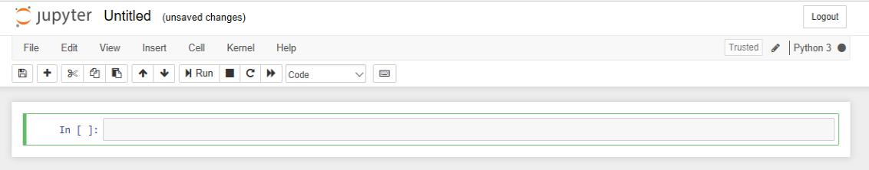

Congratulation! You lunch and open Jupyter editor successfully.

- Each cell is a code block. Once you write your code, press Shift+Enter and it will run. For example, Write print(“Hello World!”) into the first code cell.

6
All copyrights are reserved to:

Dr. Mohammed Al-Sarem & Dr. Muhanad Al-Muhameed

Lab Exercise 1: Introduction to Lab Environment

To write string like this, it is important to use quotation marks “ ”, we will see more of that in detail later.
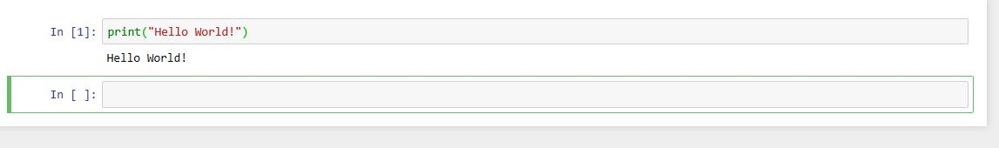

- If you want to prepare a document involving descriptions or ordinary text along with your code, you may want to change the cell type to Markdown from the drop-down menu shown below. That will change the code cell type to Markdown. After you write your text and press Shift+Enter, you will get an ordinary text instead of a code. If you know, HTML or Latex, they work well in the Markdown mode. If you want to modify a markdown block at a later time, double click on it and it will show the cell so that you can update your text.
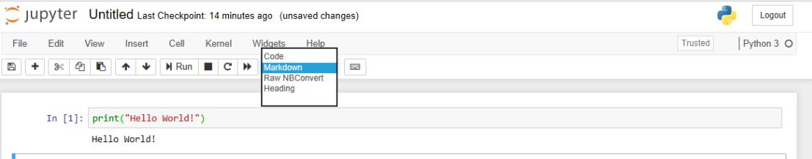

- Type the following HTML code in the cell and write down your note. <p> This is my <b> first Python code </b>.

<p> mean paragraph , and "This is my" written regular font

<b> mean bold , "first python code" written in bold font

2.1 Embedding Raw Text

Raw Text is embedded by selecting “RawNBConvert” in the toolbar dropdown list, typing text into the cell, and hitting Shift + Enter. Demonstrate here, how did you do that!

After written the text click Shift + Enter will do run to the cell
and tab to the next cell

7
All copyrights are reserved to:

Dr. Mohammed Al-Sarem & Dr. Muhanad Al-Muhameed
Lab Exercise 1: Introduction to Lab Environment

2.2 Embedding Links

Links are created by selecting “Markdown” in the toolbar dropdown list., typing text into the cell as shown below and hitting Shift + Enter.

Text |  |  | Yields
https://www.taibahu.edu.sa |  | https://www.taibahu.edu.sa
[click this link]( https://www.taibahu.edu.sa) |  | click this link
[click this link]( https://www.taibahu.edu.sa “Taibah |  | click this link
University”) |  | (shows Taibah University on
 |  | mouseover)

2.3 Embedding Formulae & Equations as LaTEX

IPython notebook uses MathJax to render LaTeX inside html/markdown. To render equations as LaTEX:

- Refer to the Mathjax Tutorial for syntax help.

- Place cursor in the cell where you want to type the equation.

- Select “Markdown” in the toolbar dropdown list.

- Type out your formula. You should wrap your formula string in ‘$$’.

- Hit Shift + Enter
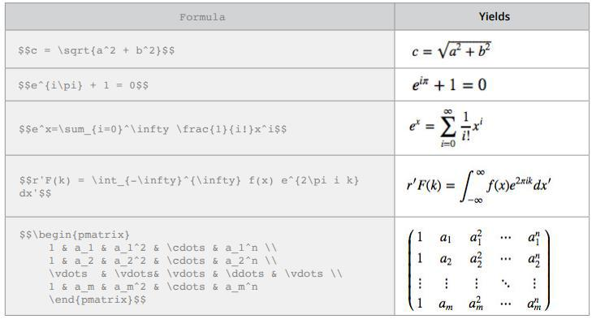

8
All copyrights are reserved to:

Dr. Mohammed Al-Sarem & Dr. Muhanad Al-Muhameed

Lab Exercise 1: Introduction to Lab Environment

Show how to display the following Equations on your Jupyter editor:
$$f(x) = a_{0}+ \sum_{n=1}^\infty (a_{n} cos\frac{n\pi x}{L} + b_{n} sin\frac{n\pi x}{L}) $$ | 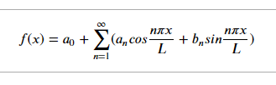
$$ (x+a)^n = \sum_{k=0}^n \begin{pmatrix} n \\ k \end{pmatrix} x^k a^{n-k} $$ | 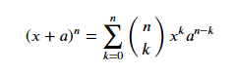

- Upload YOUR ANSWER using your account in turnitin/ by email due to the beginning of

next meeting

All the Best!!!

9
All copyrights are reserved to:

Dr. Mohammed Al-Sarem & Dr. Muhanad Al-Muhameed

